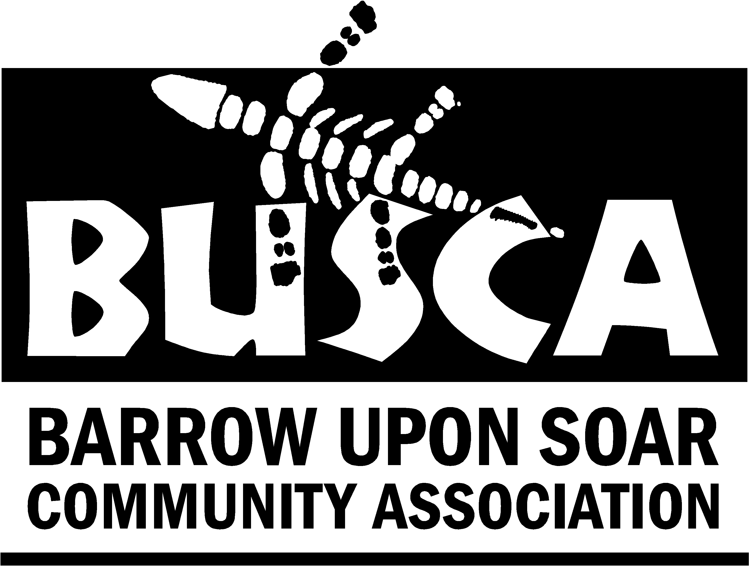

Village Hall Action Group
When the results of the parish survey were published in Summer 2006, it was clear that many residents within the village wanted a community hall that we could call our own. Recent research has indicated that there is continuing support for this initiative, particularly amongst the younger and more recent residents of Barrow. There are however a number of people who have concerns.
Some facts to start with:

- Barrow Village Hall Action Group was set up as a direct result of a need for additional facilities expressed strongly in the Barrow Parish Plan.
- The Barrow Parish Plan was a properly designed and collated survey, which was ably steered by the late Arthur Gardner. This process was brought about by the joint initiative of Barrow Parish Council and the Rural Community Council, with the backing of both Charnwood Borough and the County Council.
- The Barrow Village Hall Action Group is part of Barrow Community Association, a registered charity.

There have been rumours circulating that we hope to dispel or confirm in the following few paragraphs.
Our current community facility ( consisting of The Community Lounge, kitchen and bar, ) is attached to Humphrey Perkins High School and is entirely owned by the local authority and is now administered by the school and governors .

Many older residents still believe that this somehow belongs to the village as they remember raising money for its construction. What they have forgotten perhaps is that money raised in the village only provided part of the necessary funding and more importantly that once constructed it was handed to the Education Authority.
The village never did own it.

The arrangement worked well for many years, but latterly the emphasis on ‘community’ as in ‘local residents’ has changed and now ‘community’ in education terms is taken to mean the evening educational program. The whole concept of that has also changed in recent years, resulting in even greater implications for the local community.

Funding for Community Wardens has been completely withdrawn by the local authority. This has not only affected the local situation in Barrow but every other Community Centre in the The County. Barrow Community Centre is one of the last remaining in the county, most having been repossessed by the schools that they were attached to. Barrow has been lucky so far in having a very strong Community Association, which has been determined to keep its link with the building. The Association continues to refurbish and re-equip that area. Most particularly the Chair, Judith Rodgers has worked tirelessly to maintain a strong link with the school. In spite of this the Community Association has very few concessions either in terms of fees or access to the building.

The school has plans to develop the hall as an arts centre, which will encourage greater use of this facility by the school population and other educational establishments. This will be a great asset educationally. It will however impact upon its availability and will add to the pressure on this facility.

Groups who use the school hall (the only village venue with a stage) have found in recent years that it is often double booked or community groups are told at short notice that their booking has been cancelled. The Playgroup moved from the Community Centre because conditions were no longer suitable for them. The school obviously have to make education their first priority and quite rightly, as there would be uproar if they did not.

The local youth centre which was housed in a building on the school campus was closed sometime ago, when the school repossessed the building. Some people will remember that this was repaired and refurbished through the efforts of residents in obtaining grant funding.
Since its closure a number of residents have reported an increase in intimidating groups of youths standing around on street corners. The new community facility aims to address that.

The new community facility will be a true community centre welcoming all members of the community. It will involve the whole community from the planning stage onwards. It will be available for the use of all village groups and organisations as well as being available for private hire and it will be available throughout the day and evening.
It is hoped to provide a self-contained, dedicated, safe, exciting environment for activities which young people will enjoy.
When built it will be important to show economic and environmental sustainability and be a showcase example for other community buildings.

Some people are fearful that the cost of this project will fall upon village residents.
The Village Hall Action Group intend to raise grant funding to build the facility.
Any funding raised in this way, will be dependent upon being able to demonstrate robustly that the facility will be self-supporting and sustainable for the next 20-30 years. To this end we aim to make the facilities competitive in terms of hire and appealing in terms of aesthetics. A series of local Village Events will take place to allow local people to contribute towards their facility.

As for the charge that we will take business away from other organisations - this is not our intention. It is envisaged that most current users of existing facilities will probably stay with that provider. We would be aiming to give more choice to users and provide facilities and opportunities that do not exist at present, in response to lists of requirements which have already been given to us by interested people or which will be in the future. If you have ideas about what might be included, we would be pleased to hear from you. If you are a current provider of activities and feel that there is some facility which does not exist currently in Barrow we would like to hear from you.
We have not as yet secured land for the facility. Naturally, a central location would be the most ideal, but as of yet no such site is available.

If you are interested in this project and wish to learn about it and can offer support, please do attend our next meeting, you will be most warmly welcome. Watch out for dates and times in ‘What’s on’. All help is welcome.
We are planning to hold events throughout the year - look out for further details.

Sue Rodgers

Chair of Village Hall Action Group

